UAT Plan

for

Tilt Rush

Index

1. Scope 3

1.1. Objectives and business requirements 3

1.2. Scope 3

2. Testing team 4

3. Environmental requirements 5

3.1. Hardware requirements 5

3.2. Software requirements 5

4. Test Scripts 1

# Scope

## Objectives and business requirements

In this section, outline the business requirements. In other words:

* What are our goals? What are we hoping to accomplish with this project/feature?
* How will we measure success?

This sprint is focused on adding the goal to the gameplay in order to set up having the game begin to be able to progress and allow the player to complete levels. This will include allowing the player to enter the goal to finish the current level, have the score update and save to the stats page, and have the player and goal continuously get smaller to eventually make the game harder, once obstacles are finally added. As per previous request, I will also be adding a calibration button for ease of use.

## Scope

In this section, outline the scope. This means:

* What is the pain point we’re trying to fix?
* What are we testing exactly, and what are we *not* testing?

This sprint is used to add a functioning gameplay loop to the game, rather than just having an empty screen with the player moving aimlessly. Note that this does not mean adding any actual challenge to the game as of yet, as no obstacles will be made on this sprint.

## System Diagrams

In this section, paste any drawings or diagrams that help the UAT team understand the program being tested. With each drawing include a brief explanation of how the drawing represents the application or system being tested.

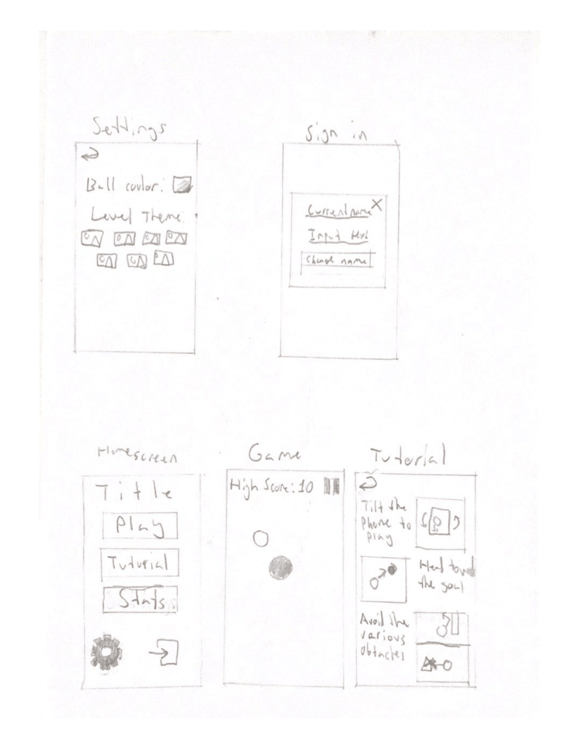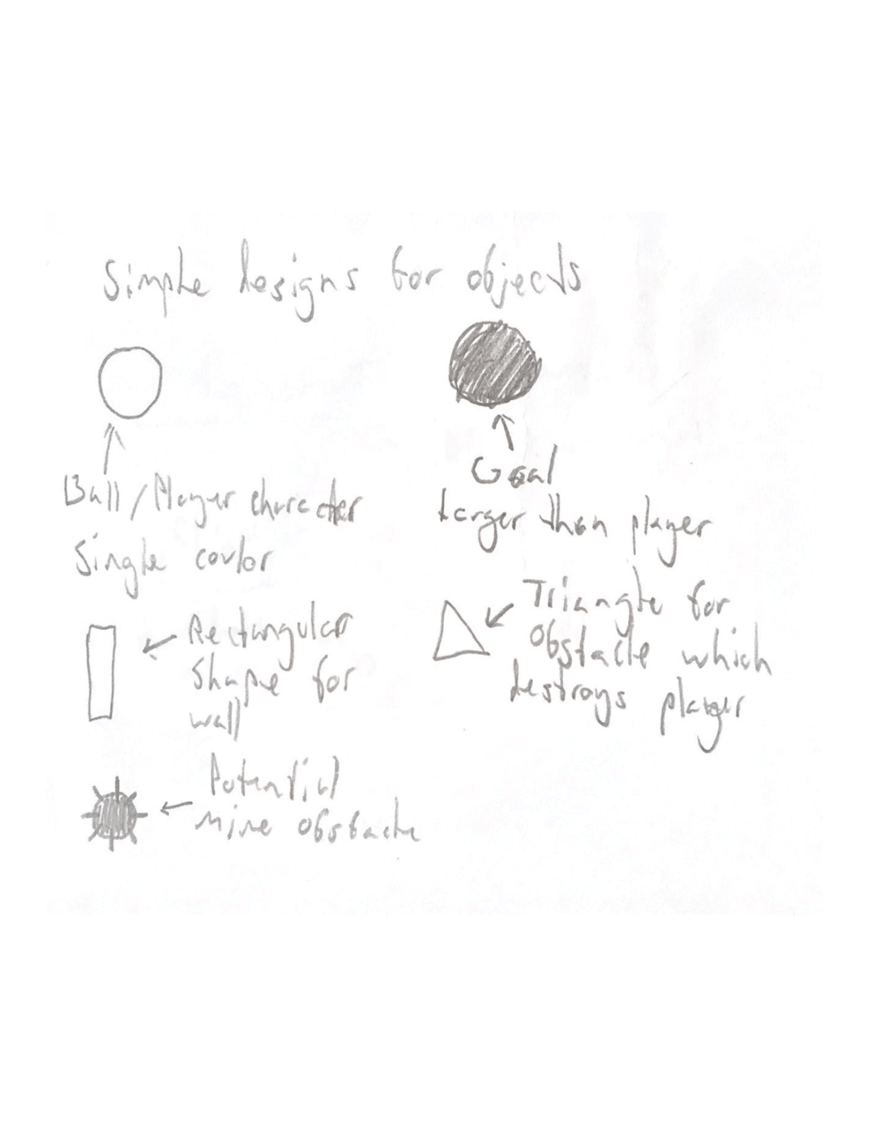

# Testing team

In this section, list out members of your QA team and what their roles will be during UAT.

Example:

| **Name** | **Responsibilities** |
| --- | --- |
| Kane Arriagada | To test the gameplay interaction between the player and the goal, and any aspects associated, as well as to test recalibration. |
| Theo Kiaris | To test the gameplay interaction between the player and the goal, and any aspects associated, as well as to test recalibration. |

# Environmental requirements

## Hardware requirements

What hardware has the solution been designed for and should be tested on.

If that is the case, outline the minimal and recommended requirements so the QA team can verify that the software runs on the testers’ machines.

Phone with online capabilities.

## Software requirements

If any extra software or dependencies must be downloaded and installed, list them here.

* Google Chrome (or similar browser)

## Network requirements

Some software (design, video editing…) can be demanding on hardware specifications.

If that is the case, outline the minimal and recommended requirements so the QA team can verify that the software runs on the testers’ machines.

* Working internet connection

# Test Scripts

This section is more important than it seems—it is crucial that both the QA team and the testers know what features must be tested, especially if you’re testing a lot at once.

| **Test** | **Describe the feature being tested** | **Describe the user input or test data** | **Describe the pass criteria** |  |
| --- | --- | --- | --- | --- |
| 5.1 | Level completion | 1. If on iOS, go to settings and click the “iOS support” button 2. Press “play” 3. Move the ball towards the goal | 1. Ball enters the goal 2. Level resets to starting positions 3. Score gets updated by 1 | Tester name: Kane Arriagada   |  | PASS | | --- | --- | |  | FAIL |   Observations:  Tester name: Theo Kiaris   |  | PASS | | --- | --- | |  | FAIL |   Observations: |
| 5.2 | Size change | 1. Continuously enter the goal over 30 times | 1. The player gets smaller upon each reset 2. The goal gets smaller upon each reset 3. Neither get smaller after score 30 | Tester name: Kane Arriagada   |  | PASS | | --- | --- | |  | FAIL |   Observations:  Tester name: Theo Kiaris   |  | PASS | | --- | --- | |  | FAIL |   Observations: |
| 5.3 | Score updating | 1. Get any score, then quit out 2. Get that same score 3. Get a different score 4. Change name 5. Get a new score 6. Get another 2 scores, one of which is lower or equal to all previously | 1. All 5 displayed scores are the highest 5 scores inputted 2. Scores accurately show correct number and name 3. Scores are ordered numerically, highest score first 4. “Total Attempts” display number of inputs added to temporary text input | Tester name: Kane Arriagada   |  | PASS | | --- | --- | |  | FAIL |   Observations:  Tester name: Theo Kiaris   |  | PASS | | --- | --- | |  | FAIL |   Observations: |
| 5.4 | Recalibration | 1. Press play with your phone in any position 2. Press the pause button 3. Press the “recalibrate” button with your phone in a new position 4. Press resume | 1. The position you place your phone which does not move the ball should now be in the spot you pressed “calibration” rather than what it started as | Tester name: Kane Arriagada   |  | PASS | | --- | --- | |  | FAIL |   Observations:  Tester name: Theo Kiaris   |  | PASS | | --- | --- | |  | FAIL |   Observations: |

Write step-by-step, detailed but concise instructions on how to test the feature.